Quiz#5

Total marks (30)

Roll#----------------------------------

Q1.The state diagram for a sequential circuit appears in Figure(10 marks)

(a) Find the state table for the circuit.

(b) Make a state assignment for the circuit using 2-bit codes and find the encoded state table.

(c) Find an optimized circuit implementation using D flip-flops, NAND gates, and inverters.

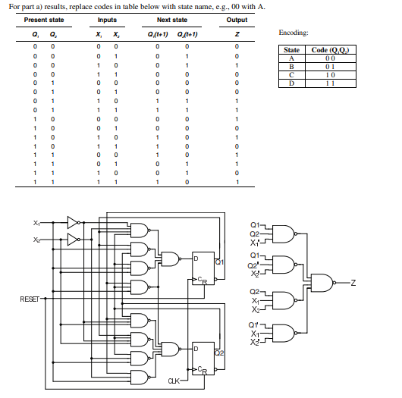

Q2. Modify the register of Figure so that it will operate according to the following function table, using mode selection inputs S1 and S0 (10 marks)

Perform sequential circuit analysis(10 marks)

(a) Draw the logic diagram of the circuit.

(b) Derive the state table.

(c) Derive the state diagram.

(d) Is this a Mealy or a Moore machine?

State diagram is missing here

